# **Chapter 1 – Introduction**

* 1. **Project Context** (Background of the project/company including organizational profile)
  2. **Technical Background** (Environment)
     1. Equipment/Hardware

The research office has six desktops in total, two printers for printing documents, and two routers for internet connectivity.

* + 1. Software

The desktop computers in the research office use Windows 10 as their operating system. Alongside Windows 10, the Microsoft Office / 365 Suite is also used. The office uses Microsoft Word for document writing, PowerPoint for presentation making and designing, Excel for data handling, data processing, and statistics, and Access for database development. Zoom and Google Meet are both used for video conferencing during important events.

* + 1. Peopleware/Manpower

Table 1

PEOPLEWARE/MANPOWER

|  |  |  |
| --- | --- | --- |
| **No.** | **User Roles** | **Responsibilities** |
| 1 | System Administrator | Responsible for managing the research information system |
| 2 | Research Adjudicator | Responsible for the approval of research submitted |
| 3 | Data Analyst | Responsible for data analysis in research and other works |
| 4 | Data Handler | Responsible for handling of research data and important documents |

The main section of the manpower of PUP Research Office is mainly on the administration side. The system administrators are responsible for managing the information system and maintaining it to keep the system in tip-top shape. The research adjudicators will be responsible for the approval and rejection of research projects. They will update the faculty / staff on the progress of their research. The Data Analyst will handle all analytical needs of the research office, while the Data Handler will be responsible for the storage and handling of all research documents, both old and new.

* + 1. Network Infrastructure/Architecture

The Research Office has a Network Infrastructure plan, which the office connects the server to the PUP Information and Communications Technology Office (ICTO).

* + 1. Storage, Backup and Recovery Procedure

Polytechnic University of the Philippines require their faculty members to fill up a form called QAR which stands for Quarterly Accomplishment Report. The QAR includes details of the progress of the ongoing advanced professional study or research that the faculty member is conducting as well as research publication, presentation, citation, utilization and Copyrighted Research Output. The QAR is filled up by the faculty every quarter of the year. This form is then passed and stored by The Office of the Vice President for Research, Extension, and Development (OVPRED). The office of the vice president records the submission of each faculty member with MS Excel as a backup then stores these physical document of the QAR by sorting and compiling them by college and then storing them in a cabinet arranged by time. If Physical documents are damaged or lost, the office can produce the lost files from the MS Excel database.

* + 1. Security Procedures

To ensure that the QAR’s information remains untampered by any individuals other than the faculty member who submitted the document him/herself, the QAR is directly passed on to the Office of the Vice President which means the document won’t have any detours. After the data has been verified, the data stored is kept in a database which cannot be accessed without authorization from the Office of the Vice President. Same goes for the Physical Documents involved in these research data. The Physical documents are kept in the office which is constantly monitored by security. The data is also kept safe by the staff of the Office of the Vice President. Any access to the research data would require proper request from the office to record its transaction.

* + 1. Policies and Procedures

The following are the policies and procedures regarding the storage of research progress information.

1. The QAR is submitted by every faculty member of the university every quarter of the year.
2. The QAR is kept by The Office of the Vice President for Research, Extension, and Development (OVPRED).
3. The data of the QAR can be provided by the OVPRED depending on the level of the individual requesting for the data. The Dean can access the research information of the faculty members that are in their particular college while the chairperson can access all of QAR data.
4. A faculty member can request for these data by submitting a request.
5. The Office of the Vice President cannot change the information on the QAR submissions.
6. The QAR submissions will first be verified by the Office of the Vice President for its validity and authenticity before storing them in the database.
7. A faculty member can submit multiple research information as long as it is truly conducted.
8. The research publication, presentation, citation, and utilization can come from an already existing research in the database as long as the faculty member is involved in it.
9. The faculty member can submit a completed research report and also submit its other accomplishments at the same time such as the research’s publication or presentation.
   * 1. Data and Process

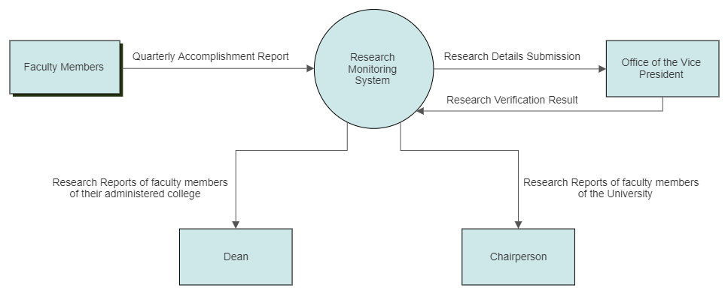

Figure 1: Context Diagram

The data that is utilized in this system will come from the Quarterly Accomplishment Report that is submitted by every faculty member in the University. The Office of the Vice President Collects these submissions and verifies the validity of the submission.

The Dean can access the research data of their college while the Chairperson can access all of the University’s research information.

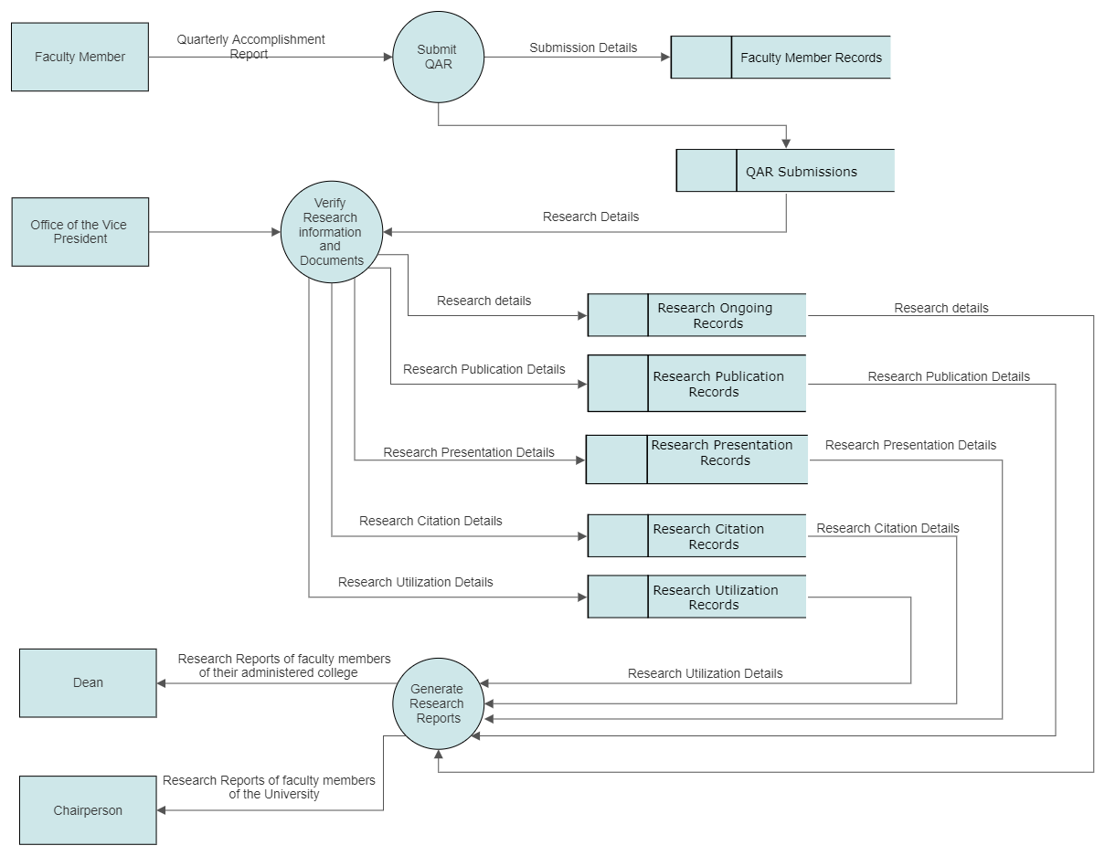

Figure 2: Data Flow Diagram Level 1

The Quality Assurance Report includes all of the faculty member’s activities in a quarter of the work year. This includes attendance, Trainings, Seminars, or memberships. From the QAR, the research segment is used to monitor the research progress of every faculty member, which are the Ongoing Research/Study, Research Presentation, Research Publication, Research Citation, Research Utilization, and Copyrighted Research Output. This is then verified by The office of the Vice President before storing the data. From These data, reports can be generated depending on the level of access of the faculty requesting.

* 1. **Problem Analysis**
     1. Fishbone Diagram (diagram with textual /narrative discussion)
     2. Problem and Solution Statement (formal statement of root of the problem derived from the fishbone analysis and proposed IT-related solution to address the problem identified)
     3. Problem – Requirements Matrix (Mapping of list of problems to requirements that will address the problem/s)
  2. **Purpose and Description** (To propose a solution to…)
  3. **Specific Objectives**

1. To enumerate the problems…
2. To evaluate the existing…
3. To propose a …
4. To identify the requirements of the proposed …
5. To design a …
   1. **Scope and Limitations** (of the problem domain)

# **Chapter 2 – Review of Related Literature/Systems**

(narrative and thematically arranged reflecting the proponent’s knowledge of the solution domain based on critical analysis of existing literature/systems to identify basic requirements, innovative features and possible improvements on existing technologies/systems)

# **Chapter 3 – Methodology**

* 1. **Requirements Analysis** 
     1. Requirements – Features Matrix
     2. Use Case Diagram
     3. Use Case Report
  2. **Design Specifications** 
     1. Activity Diagram (per use case)
     2. Class Diagram (per use case)
     3. GUI Design (screen shots)
     4. Database Schema
     5. Data Dictionary
  3. **Development Methodology** 
     1. Process Model – (waterfall, incremental, fountain, etc.)
     2. Development Tools – (PLs, DBs, IDEs, frameworks, APIs, generators and other dev’t tools)
  4. **Test Methodology/Procedures** – (testing technique, methods and procedures of development team)
  5. **System Requirements** (hardware, software, other components for system implementation)
  6. **Quality Plan** – (procedure and instrument that will be considered in assessing the quality of the system i.e. ISO 9126, FURPS, etc.)
  7. **Evaluation Plan** - (specify schedule, procedure, and users for the evaluation of the system)

# **Chapter 4 – Results and Discussion**

(Discusses and explains results on evaluation of system and factors affecting the results)

# **Chapter 5 – Conclusions and Recommendations**

(Provides conclusion based on results of evaluation and recommendation to future developers)

**APPENDICES**

APPENDIX A

**DATA GATHERING INSTRUMENT**

(include pictures as proof)

APPENDIX B

**CLIENT FORMS AND REPORTS**

APPENDIX C

**EVALUATION TOOL, TEST DOCUMENTS AND TEST RESULTS**

APPENDIX D

**USER'S MANUAL**

APPENDIX E

**SAMPLE SYSTEM GENERATED OUTPUTS**

APPENDIX F

**RESUME**

(one page Resume of each member of the group in alphabetical order)